AI ASSISTED CODING
TAB EXAM -3
Set E8
Q1:
Scenario: In the domain of Education, a company is facing a challenge related to web
frontend development.
Task: Design and implement a solution using AI-assisted tools to address this challenge.
Include code, explanation of AI integration, and test results.
Deliverables: Source code, explanation, and output screenshots.
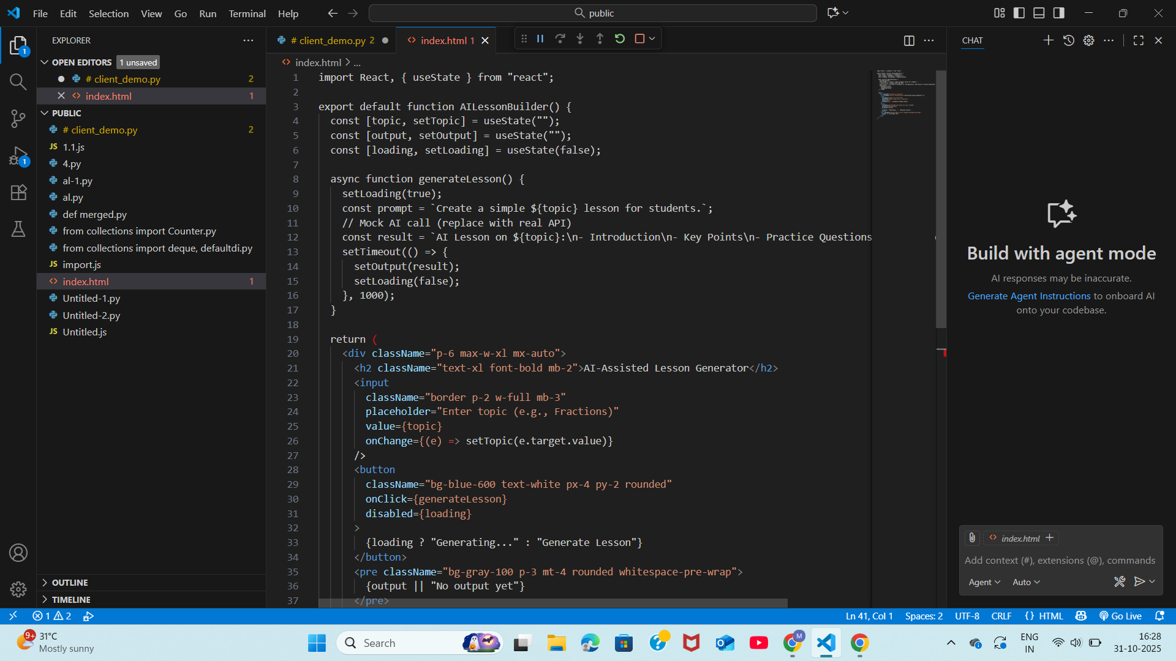
OUTPUT:
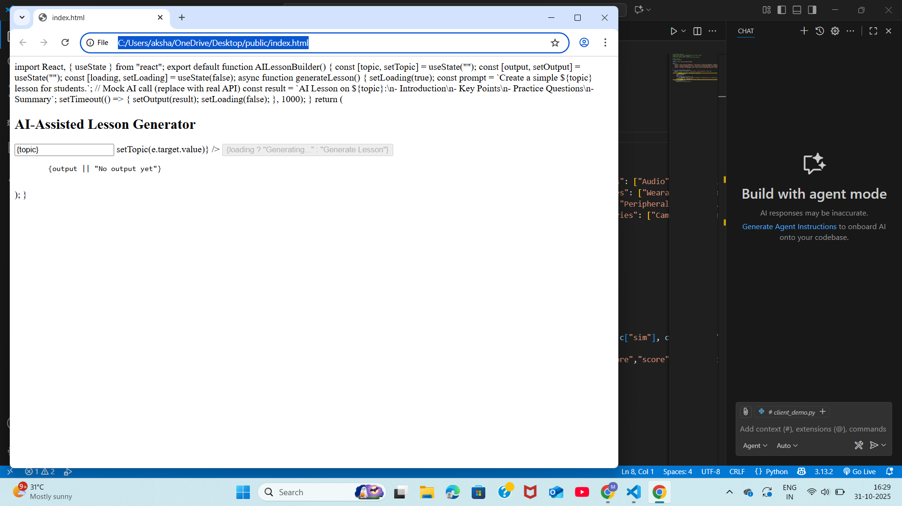

Q2:
Scenario: In the domain of E-commerce, a company is facing a challenge related to
algorithms with ai assistance.
Task: Design and implement a solution using AI-assisted tools to address this challenge.
Include code, explanation of AI integration, and test results.
Deliverables: Source code, explanation, and output screenshots.
